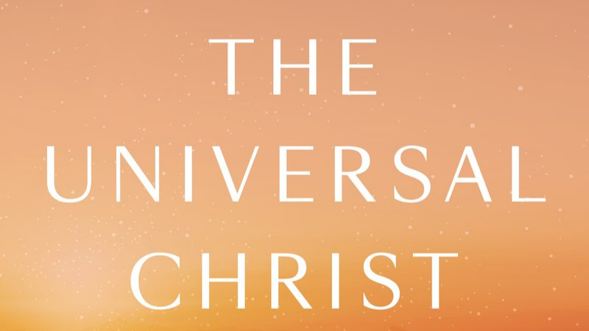

a book by Fr. Richard Rohr
provides an Eight Week Study for Spiritual Growth

This Lenten Season join in fellowship, and exploration with Jesus, The Resurrection, The Christ, and what it means that Jesus was called “Christ”

Thursdays, February 13, 20, 27, March 12, 19, 26, April 2, 16 2020, 6:30PM TO 8:00PM
Fireside room UCC

THERE IS NO COST for the study
THE BOOKS COST ABOUT $20
You are invited to join us as we explore the sacredness surrounding us
that Christ invites us to experience
contact Sandee Meade 509-447-2693

